Bahria University,

Karachi Campus



LAB EXPERIMENT NO.

**2**

LIST OF TASKS

|  |  |
| --- | --- |
| TASK NO | OBJECTIVE |
| **1** | **Write a Python program that calculates the absolute as well as relative error present in the following measurements** |
| **2** | **Write a Python program the find the propagated error in the area and perimeter found for the following measurements** |
| **3** | **Write a Python program that calculates the square root of following numbers using both the math.sqrt function (which uses floating-point arithmetic) and a custom square root function that uses integer arithmetic. Then, find and compare the results to observe the rounding error.** |
| 4 | Write a python program which find the value of PI (π) using Taylor series, and then find the truncating error occurred due to the use of finite number of terms. |

Submitted On:

**Date: ___________**

**Task No. 01:**

**Write a Python program that calculates the absolute as well as relative error present in the following measurements;**

**Actual values: [11.0098, 167.902, 56.0567, 67.9860]**

**Measured values: [12.0001, 166.802, 55.0001, 69.0000]**

**Solution:**

def absolute_error(actual,measured):

return abs(actual-measured)

def realtive_error(actual,measured):

return abs((absolute_error(actual,measured)/actual)*100)

actual_values = [11.0098, 167.902, 56.0567, 67.9860]

measured_values = [12.0001, 166.802, 55.0001, 69.0000]

absolute_errors=[]

realtive_errors=[]

for i in range(len(actual_values)):

absolute_errors.append(absolute_error(actual_values[i],measured_values[i]))

realtive_errors.append(absolute_error(actual_values[i],measured_values[i]))

print('Absolute Errors: ',absolute_errors)

print('Relative Errors: ',realtive_errors)

**Output:**

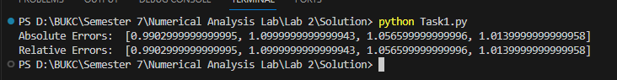

**Task No. 02:**

**Write a Python program the find the propagated error in the area and perimeter found for the following measurements:**

**SQUARE (length: 45.09 cm; uncertainty: 0.01 cm)**

**CIRCLE (radius: 34.90 cm; uncertainty: 0.05 cm)**

**TRIANGLE (side1: 70.9 m; uncertainty: 0.23 m, side2: 89.07cm; uncertainty: 0.07 m,**

**base: 76.07cm; uncertainty: 0.04 m, height: 100.07cm; uncertainty: 0.05 m)**

**- TRAPEZIUM (side1: 670.9 m; uncertainty: 0.53 m (parallel one), side2: 849.07cm; uncertainty: 0.27 m (parallel one) side3: 376.07cm; uncertainty: 0.74 m, side4: 716.07cm; uncertainty: 0.14 m, height: 231.07cm; uncertainty: 0.25 m)**

**Solution:**

import math

def square_area_perimeter(length, length_error):

area = length**2

perimeter = 4 * length

area_error = 2 * length * length_error

perimeter_error = 4 * length_error

return area, perimeter, area_error, perimeter_error

def circle_area_perimeter(radius, radius_error):

area = math.pi * radius**2

perimeter = 2 * math.pi * radius

area_error = 2 * math.pi * radius * radius_error

perimeter_error = 2 * math.pi * radius_error

return area, perimeter, area_error, perimeter_error

def triangle_area_perimeter(side1, side2, base, height, side1_error, side2_error, base_error, height_error):

area = 0.5 * base * height

perimeter = side1 + side2 + base

area_error = 0.5 * height * (base_error + height_error) + 0.5 * base * height_error

perimeter_error = side1_error + side2_error + base_error

return area, perimeter, area_error, perimeter_error

def trapezium_area_perimeter(side1, side2, side3, side4, height, side1_error, side2_error, side3_error, side4_error, height_error):

area = 0.5 * (side1 + side3) * height

perimeter = side1 + side2 + side3 + side4

area_error = 0.5 * height * (side1_error + side3_error) + 0.5 * (side1 + side3) * height_error

perimeter_error = side1_error + side2_error + side3_error + side4_error

return area, perimeter, area_error, perimeter_error

length_sq = 45.09

length_error_sq = 0.01

radius_circ = 34.90

radius_error_circ = 0.05

side1_tri = 70.9

side2_tri = 89.07

base_tri = 76.07

height_tri = 100.07

side1_error_tri = 0.23

side2_error_tri = 0.07

base_error_tri = 0.04

height_error_tri = 0.05

side1_trap = 670.9

side2_trap = 849.07

side3_trap = 376.07

side4_trap = 716.07

height_trap = 231.07

side1_error_trap = 0.53

side2_error_trap = 0.27

side3_error_trap = 0.74

side4_error_trap = 0.14

height_error_trap = 0.25

area_sq, perimeter_sq, area_error_sq, perimeter_error_sq = square_area_perimeter(length_sq, length_error_sq)

area_circ, perimeter_circ, area_error_circ, perimeter_error_circ = circle_area_perimeter(radius_circ, radius_error_circ)

area_tri, perimeter_tri, area_error_tri, perimeter_error_tri = triangle_area_perimeter(side1_tri, side2_tri, base_tri, height_tri, side1_error_tri, side2_error_tri, base_error_tri, height_error_tri)

area_trap, perimeter_trap, area_error_trap, perimeter_error_trap = trapezium_area_perimeter(side1_trap, side2_trap, side3_trap, side4_trap, height_trap, side1_error_trap, side2_error_trap, side3_error_trap, side4_error_trap, height_error_trap)

print('Square:')

print('Area:', area_sq, 'cm^2 (±', area_error_sq, 'cm^2)')

print('Perimeter:', perimeter_sq, 'cm (±', perimeter_error_sq, 'cm)')

print('Circle:')

print('Area:', area_circ, 'cm^2 (±', area_error_circ, 'cm^2)')

print('Perimeter:', perimeter_circ, 'cm (±', perimeter_error_circ, 'cm)')

print('Triangle:')

print('Area:', area_tri, 'cm^2 (±', area_error_tri, 'cm^2)')

print('Perimeter:', perimeter_tri, 'cm (±', perimeter_error_tri, 'cm)')

print('Trapezium:')

print('Area:', area_trap, 'cm^2 (±', area_error_trap, 'cm^2)')

print('Perimeter:', perimeter_trap, 'cm (±', perimeter_error_trap, 'cm)')

**Output:**

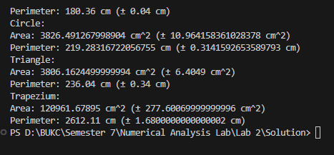

**Task No. 03:**

**Write a Python program that calculates the square root of following numbers using both the math.sqrt function (which uses floating-point arithmetic) and a custom square root function that uses integer arithmetic. Then, find and compare the results to observe the rounding error.**

**(56.90, 100.45, 67.90, 25.67, 56.67)**

**Solution:**

import math

def difference(list1):

actual_sq=[]

measured_sq=[]

diffList=[]

for i in range(len(list1)):

actual_sq.append(math.sqrt(list1[i]))

measured_sq.append(list1[i]**(1/2))

diff=actual_sq[i]-measured_sq[i]

diffList.append(diff)

return actual_sq,measured_sq,diffList

list1=[56.90, 100.45, 67.90, 25.67, 56.67]

actual_square_root, measured_square_root, differences = difference(list1)

print("Input Values:", list1)

print("Actual Square Roots:", actual_square_root)print("Measured Square Roots:", measured_square_root)print("Differences:", differences)

**Output:**

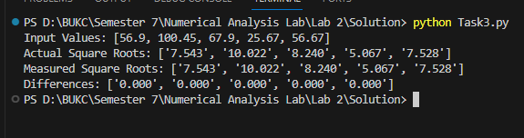

**Task No. 04:**

**Write a python program which find the value of PI (π) using Taylor series, and then find the truncating error occurred due to the use of finite number of terms.**

**HINT: arctan (1) = π/4, and formula for finding Tylor series for arctan is:**

**𝐚𝐫𝐜𝐭𝐚𝐧(𝐱)= Σ (−1) 𝑛𝑧2𝑛+12𝑛+1; ∞𝑛=0 |z|≤1, z ≠i,i**

**Solution:**

import math

def arcTan(x,N):

res=0.0

for i in range(N):

n=(((-1)**i)*(x**((2*i)+1)))/((2*i)+1)

res+=n

return res

print('Actual PI: ',math.pi)

terms=100

approx_pi=4*arcTan(1,terms)

print('Approximate Value of PI: ',approx_pi)

truncationError=abs(approx_pi-math.pi)

print('Truncation Error: ',truncationError)

**Output:**

